https://en.wikipedia.org/wiki/Cloud_computing:
IAAS (Infrastructure as a Service)
(From Wikipedia, the free encyclopedia)
Cloud computing is a computing infrastructure and software model for enabling ubiquitous access to shared pools of configurable resources (e.g., computer networks, servers, storage, applications and services),^{[1][2]} which can be rapidly provisioned with minimal management effort, often over the Internet. Cloud computing allows users, and enterprises, with various computing capabilities to store and process data in either a privately owned cloud, or on a third-party server located in a data center in order to make data accessing mechanisms more efficient and reliable.^{[3]} Cloud computing relies on sharing of resources to achieve coherence and economy of scale, similar to a utility.
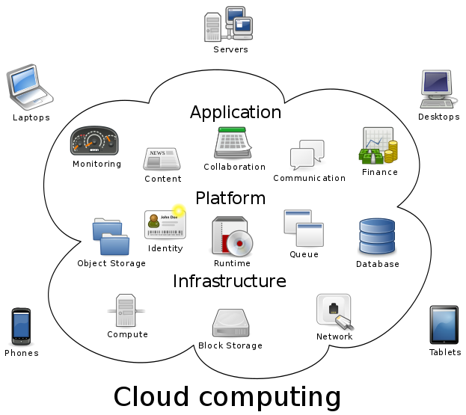
Advocates note that cloud computing allows companies to avoid, or minimize, up-front infrastructure costs. As well, third party clouds enable organizations to focus on their core businesses instead of expending resources on computer infrastructure and maintenance.^{[4]} Proponents also claim that cloud computing allows enterprises to get their applications up and running faster, with improved manageability and less maintenance, and enables information technology (IT) teams to more rapidly adjust resources to meet fluctuating and unpredictable business demand.^{[4][5][6]} Cloud providers typically use a "pay as you go" model. This could lead to unexpectedly high charges if administrators are not familiarized with cloud pricing models.^{[7]}
In 2009, the availability of high-capacity networks, low-cost computers and storage devices as well as the widespread adoption of hardware virtualization, service-oriented architecture, and autonomic and utility computing led to a growth in cloud computing.^{[8][9][10]} Companies can scale up as computing needs increase and then scale down again as demands decrease.^{[11]} In 2013, it was reported that cloud computing had become a highly demanded service or utility due to the advantages of high computing power, cheap cost of services, high performance, scalability, accessibility as well as availability. Some cloud vendors are experiencing growth rates of 50% per year,^{[12]} but being still in a stage of infancy, it has pitfalls that need to be addressed to make cloud computing services more reliable and user friendly.^{[13][14]}

Categories:
Cloud computing |  | Cloud infrastructure

